TestNG Results Plugin:

We have seen the results produced under surefire-reports in Eclipse.

TestNG Results plugin provides some addintional fetures for reports.

Go to Manage Jenkins section and click on “Manage Plugins” link.

Go to the “Available” tab and search with the words “TestNG Results” and it will show you the plugin.

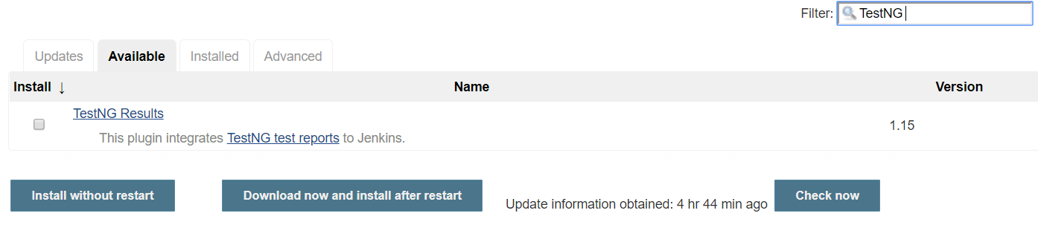

Select the plugin and click on “Install without restart”.

Once the plugin is started go to the configuration section of any job and go to the Post Build Actions.

Post Build Actions means any action that has to be taken once the job is completed. Click on “Add Post-Build Action” and select the “Publish TestNG results” option and save it.

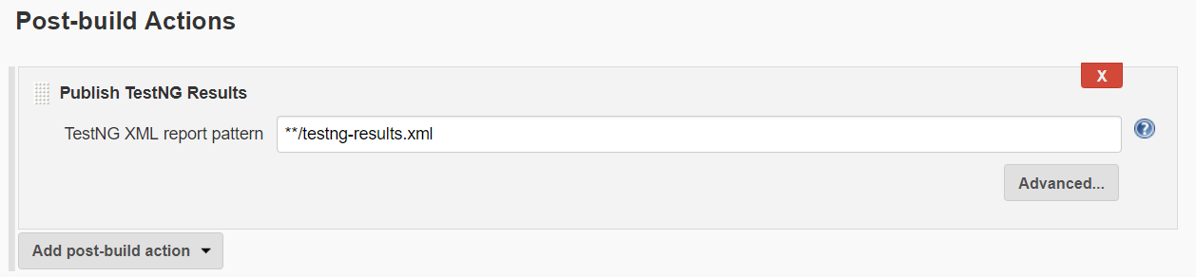

Now run the job manually.

Once the job is completed, go to the job and on left side you will see the link TestNG results.

Clcik on the link and you will see the test results like how many test cases are passed, how many are failed etc..

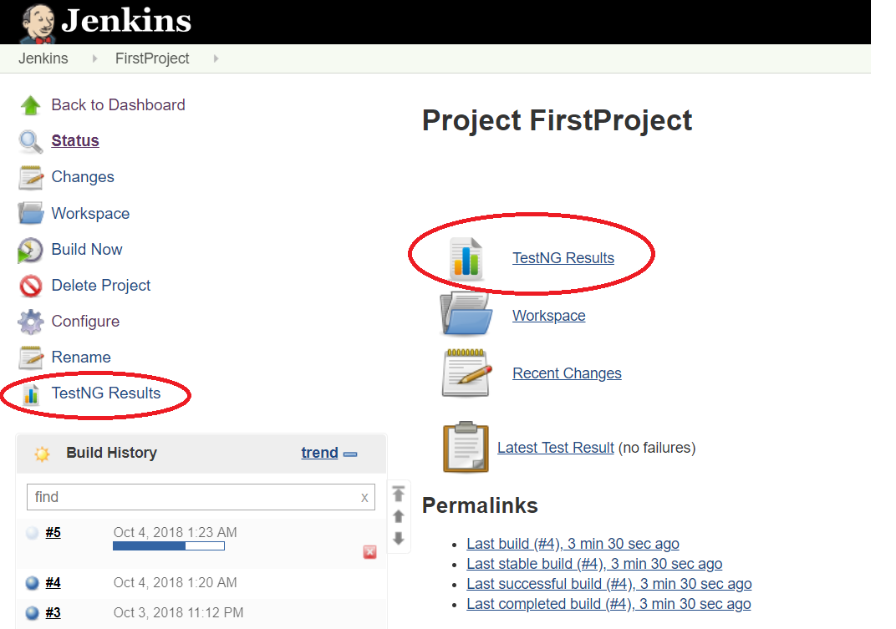

Click on TestNG Results.

On this page and you will see the results.